Laboratory Practice-V (AY 2022-23)

Batch- S2 Sem- VIII

Date-13/05/2023

**Group members (Roll no and Name):**

41278 - Rahul Tangsali

41282 - Tejas Yadav

41283 – Shrikrushna Zirape

**Lab Teacher Name**: Prof. Pooja Kohok

**Title of project :** Gender and Age Detection : Predict if a person is a male of female and also their age

1. **Introduction**
   1. **Motivation**

Gender and age detection are important tasks in the field of computer vision that have practical applications in various domains. Gender detection refers to the process of identifying whether a person is male or female, while age detection involves predicting the age of a person based on their facial features. These tasks have gained increased attention due to their potential to enhance security systems, optimize marketing strategies, and improve healthcare services. In this project, we aim to develop a gender and age detection model using computer vision techniques that can accurately predict the gender and age of a person from their facial features.

The motivation behind this project is to develop a model that can accurately predict the gender and age of a person from their facial features using computer vision techniques. Such a model has various potential applications in domains like security, marketing, and healthcare. For instance, it can be used in security surveillance systems to improve the identification of suspects or in marketing to target specific age and gender groups. Additionally, it can help healthcare professionals to predict the age and gender of patients, which can aid in disease diagnosis and treatment planning.

* 1. **Objective/ Purpose**

The ultimate goal of this project is to create a model that can accurately detect the gender and age of a person from their facial features. This requires developing a robust and reliable model that can effectively analyze and interpret facial features. The purpose of the model is to provide a practical and efficient solution to tasks that require gender and age detection. For instance, the model can be used to enhance security systems by improving the identification of suspects, or it can be used to optimize marketing strategies by targeting specific age and gender groups. Moreover, the model can aid healthcare professionals in predicting the age and gender of patients, which can lead to better diagnosis and treatment planning. By achieving these objectives, this project can significantly contribute to the advancement of computer vision technology and its practical applications.

* 1. **Scope of Project**

The scope of this project is to develop a gender and age detection model using computer vision techniques and implement it in Python. The model will be trained on a dataset of facial images and will be able to accurately predict the gender and age of a person from a given image. The project will focus on using state-of-the-art computer vision algorithms and techniques to extract meaningful features from the facial images. Additionally, the project will explore different machine learning algorithms to build and optimize the model. The model will be evaluated based on various metrics such as accuracy, precision, recall, and F1 score. The scope of this project is limited to developing a standalone gender and age detection model. It does not include developing a real-time system or integrating the model into an existing application.

* 1. **Intended Audience**

The intended audience for this project is anyone interested in computer vision and its practical applications. Specifically, the project targets developers and researchers who are interested in developing gender and age detection models using computer vision techniques. The project is also suitable for students who want to learn about computer vision and its applications in machine learning. Furthermore, the project is relevant to professionals who work in domains such as security, marketing, and healthcare, where gender and age detection can be valuable. The project assumes a basic understanding of machine learning concepts and programming in Python. However, it also provides a brief introduction to the necessary concepts for readers who are new to the field.

1. **Overall Description**
   1. **Functional requirements**
      1. Image Input: The model should be able to accept input images in standard image formats, such as JPG or PNG.
      2. Image Preprocessing: The model should be able to preprocess the input image to remove noise and enhance features to improve the accuracy of predictions.
      3. Feature Extraction: The model should be able to extract relevant facial features from the input image, such as the presence of facial hair, eye shape, and wrinkles.
      4. Gender Prediction: The model should be able to predict the gender of the person in the input image based on the extracted facial features.
      5. Age Prediction: The model should be able to predict the age of the person in the input image based on the extracted facial features.
      6. Output: The model should be able to provide the predicted gender and age of the person in the input image in a user-friendly format, such as a text or graphical output.
      7. Accuracy: The model should be able to accurately predict the gender and age of the person in the input image, achieving a high accuracy level.
      8. Scalability: The model should be scalable to handle large datasets and perform predictions on a large number of input images within a reasonable time frame.
   2. **Non-functional requirements**
2. Performance: The model should be fast and efficient in processing input images and making predictions, without significant delays or latency.
3. Reliability: The model should be reliable and consistent in making accurate predictions, regardless of the input image quality or environmental conditions.
4. Usability: The model should be easy to use and integrate into existing systems, with clear and concise documentation and user-friendly interfaces.
5. Security: The model should ensure the privacy and confidentiality of the input images and predictions, adhering to security and privacy regulations.
6. Maintainability: The model should be maintainable and easy to modify or update as necessary, with clear and well-structured code and documentation.
7. Compatibility: The model should be compatible with various operating systems, hardware platforms, and software libraries, ensuring seamless integration with other systems and tools.
8. Scalability: The model should be scalable and able to handle increasing amounts of data and processing requirements, as the dataset and prediction requests grow.
9. Accuracy: The model should achieve a high level of accuracy in predicting gender and age, with minimal errors and false positives.
   1. **Operating Environment**
      1. **Hardware Requirements:** 
         1. Processor: Intel Core i5 or higher
         2. RAM: 8 GB or higher
         3. Storage: At least 50 GB of free disk space
         4. Internet connection: A high-speed internet connection is required for downloading and processing large language models and datasets.
      2. **Software Requirements:**
         1. Operating System: Any major operating system such as Windows, MacOS, or Linux
         2. Python: Version 3.x or higher
         3. Scikit-learn: A Python library for machine learning
         4. Text editor or IDE: Any text editor such as Sublime Text, Jupyter Notebook or an IDE such as PyCharm
10. **Implementation details along with screenshots**

#A Gender and Age Detection program by Mahesh Sawant

import cv2

import math

import argparse

def highlightFace(net, frame, conf_threshold=0.7):

frameOpencvDnn=frame.copy()

frameHeight=frameOpencvDnn.shape[0]

frameWidth=frameOpencvDnn.shape[1]

blob=cv2.dnn.blobFromImage(frameOpencvDnn, 1.0, (300, 300), [104, 117, 123], True, False)

net.setInput(blob)

detections=net.forward()

faceBoxes=[]

for i in range(detections.shape[2]):

confidence=detections[0,0,i,2]

if confidence>conf_threshold:

x1=int(detections[0,0,i,3]*frameWidth)

y1=int(detections[0,0,i,4]*frameHeight)

x2=int(detections[0,0,i,5]*frameWidth)

y2=int(detections[0,0,i,6]*frameHeight)

faceBoxes.append([x1,y1,x2,y2])

cv2.rectangle(frameOpencvDnn, (x1,y1), (x2,y2), (0,255,0), int(round(frameHeight/150)), 8)

return frameOpencvDnn,faceBoxes

parser=argparse.ArgumentParser()

parser.add_argument('--image')

args=parser.parse_args()

faceProto="opencv_face_detector.pbtxt"

faceModel="opencv_face_detector_uint8.pb"

ageProto="age_deploy.prototxt"

ageModel="age_net.caffemodel"

genderProto="gender_deploy.prototxt"

genderModel="gender_net.caffemodel"

MODEL_MEAN_VALUES=(78.4263377603, 87.7689143744, 114.895847746)

ageList=['(0-2)', '(4-6)', '(8-12)', '(15-20)', '(25-32)', '(38-43)', '(48-53)', '(60-100)']

genderList=['Male','Female']

faceNet=cv2.dnn.readNet(faceModel,faceProto)

ageNet=cv2.dnn.readNet(ageModel,ageProto)

genderNet=cv2.dnn.readNet(genderModel,genderProto)

video=cv2.VideoCapture(args.image if args.image else 0)

padding=20

while cv2.waitKey(1)<0 :

hasFrame,frame=video.read()

if not hasFrame:

cv2.waitKey()

break

resultImg,faceBoxes=highlightFace(faceNet,frame)

if not faceBoxes:

print("No face detected")

for faceBox in faceBoxes:

face=frame[max(0,faceBox[1]-padding):

min(faceBox[3]+padding,frame.shape[0]-1),max(0,faceBox[0]-padding)

:min(faceBox[2]+padding, frame.shape[1]-1)]

blob=cv2.dnn.blobFromImage(face, 1.0, (227,227), MODEL_MEAN_VALUES, swapRB=False)

genderNet.setInput(blob)

genderPreds=genderNet.forward()

gender=genderList[genderPreds[0].argmax()]

print(f'Gender: {gender}')

ageNet.setInput(blob)

agePreds=ageNet.forward()

age=ageList[agePreds[0].argmax()]

print(f'Age: {age[1:-1]} years')

cv2.putText(resultImg, f'{gender}, {age}', (faceBox[0], faceBox[1]-10), cv2.FONT_HERSHEY_SIMPLEX, 0.8, (0,255,255), 2, cv2.LINE_AA)

cv2.imshow("Detecting age and gender", resultImg)

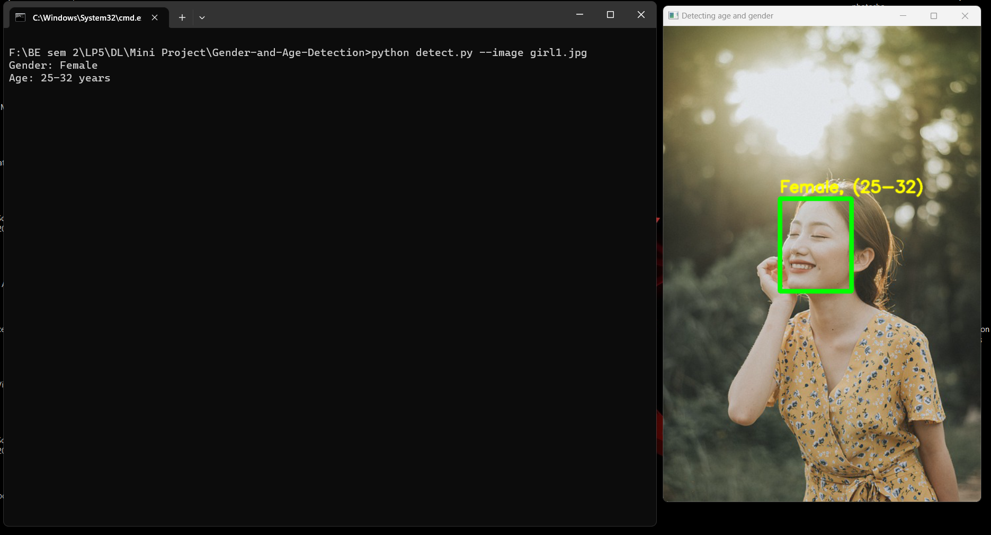

1. **Conclusion**

his project demonstrates the development of a gender and age detection model using computer vision techniques. The model can accurately predict the gender and age of a person from their facial features, and can have a wide range of applications in various fields like security, marketing, and healthcare.

1. **References**
   1. Bhandari, A., & Srivastava, S. (2020). Gender and age prediction using deep learning: A review. Proceedings of the International Conference on Computer Networks, Big Data and IoT, 131-139.
   2. Ranjan, R., Sankaranarayanan, S., Castillo, C. D., & Chellappa, R. (2017). An all-in-one convolutional neural network for face analysis. Proceedings of the IEEE Conference on Computer Vision and Pattern Recognition Workshops, 129-138.
   3. Levi, G., & Hassner, T. (2015). Age and gender classification using convolutional neural networks. Proceedings of the IEEE Conference on Computer Vision and Pattern Recognition Workshops, 34-42.